- Create a Database called music
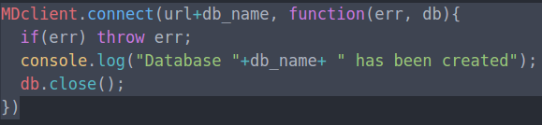

- Create a collection called songdetails
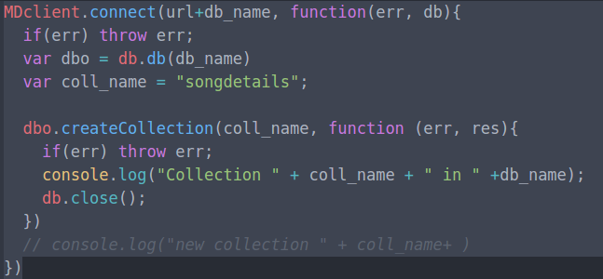

- Create the above 5 song documents.
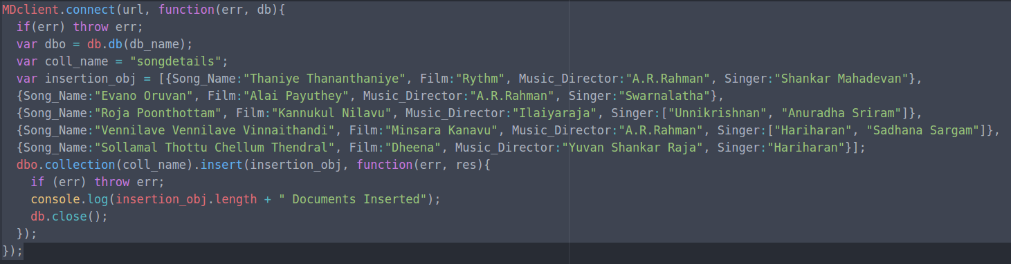
- List all documents created.
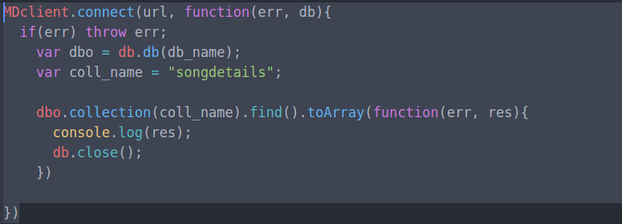
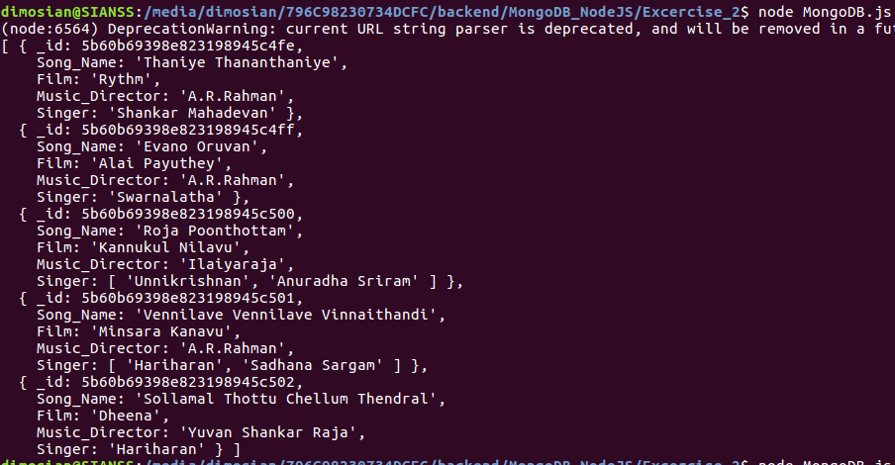
- List A.R.Rahman’s songs.
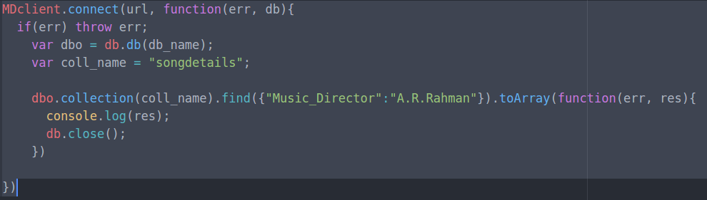
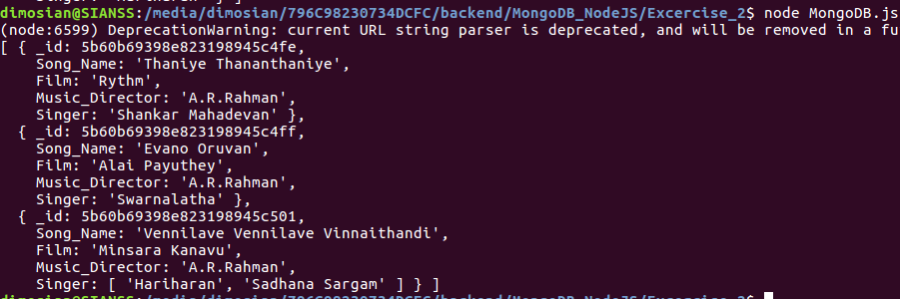
- List A.R.Rahman’s songs sung by Unnikrishnan.

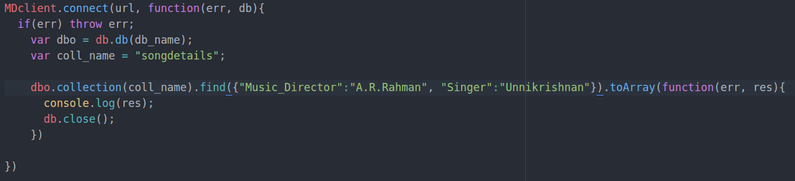

- Delete the song which you don’t like.
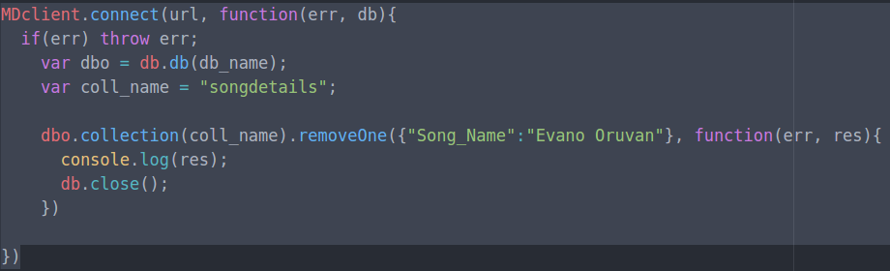
- Add new song which is your favourite.
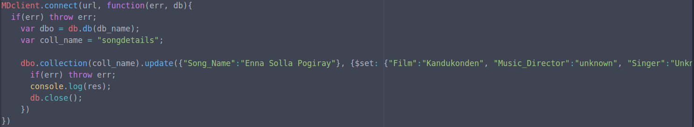

- List Songs sung by Hariharan from Minsara kanavu film.
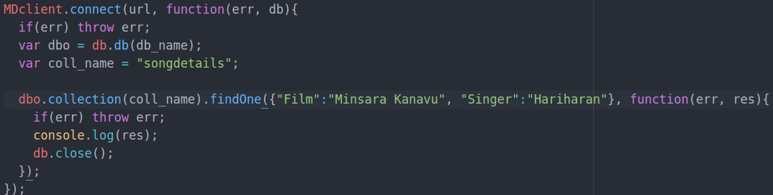
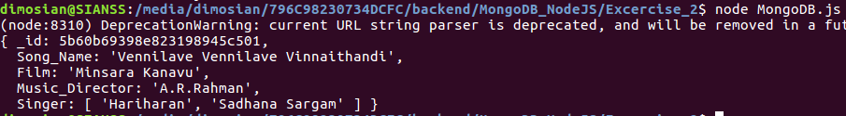
- List out the singers’ names in your document.
